Sums

simple regression

Multiple regression

Tf-Idf

Module 2: Logistic Regression

## Logistic Regression

Logistic regression is a **statistical method** that is used for building machine learning models where the d**ependent variable is dichotomous: i.e. binary.**

Logistic regression is used to describe data and the relationship between one dependent variable and one or more independent variables. The independent variables can be continuous, nominal, discrete, ordinal, or of interval type

The outcome variable is binary. The purpose of the analysis is to assess the effects of multiple explanatory variables, which can be numeric and/or categorical, on the outcome variable.

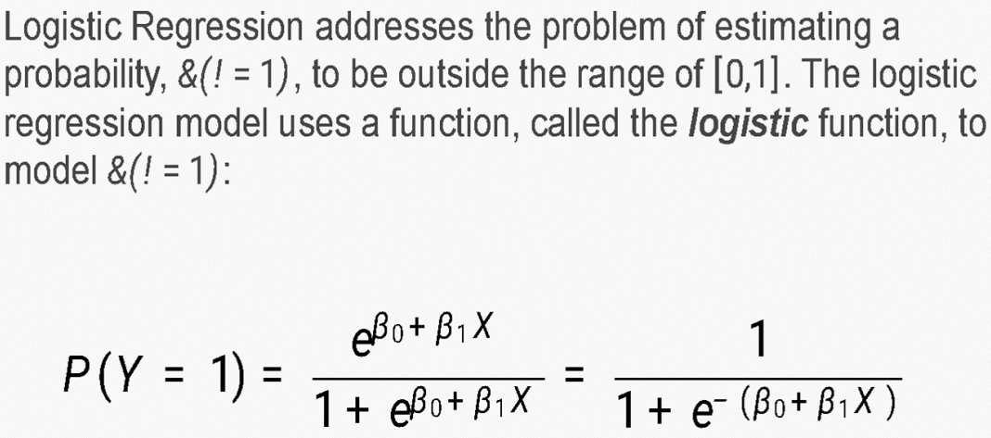

## **Types of Logistic Regression**

1. Binomial logistic

The dependent variable is binary in nature.

For example, the output can be Success/Failure, 0/1, True/False, or Yes/No.

1. Multinomial logistic regression

when you have one categorical dependent variable with two or more unordered levels (i.e two or more discrete outcomes.

For example, let’s imagine that you want to predict what will be the most-used transportation type in the year 2030. The transport type will be the dependent variable, with possible outputs of train, bus, tram, and bike (for example).

1. Ordinal logistic regression

when the dependent variable (Y) is ordered (i.e., ordinal).

The dependent variable has a meaningful order and more than two categories or levels.

Examples of such variables might be t-shirt size (XS/S/M/L/XL), answers on an opinion poll (Agree/Disagree/Neutral), or scores on a test (Poor/Average/Good).

## Concept of Probability

The probability of the outcome is measured by the odds of the occurrence of an event.

If P is the probability of an event, then (1-P) is the probability of it not occurring.

Odds of success = P / 1-P

odds are the chances of success divided by the chances of failure.

It is represented in the form of a ratio.

Odds\ Ratio = p/1-p

where, p -> success odds 1-p -> failure odds

## Logistic Response function and logit,

Log odds play an important role in logistic regression as it converts the LR model from a probability-based to a likelihood-based model. Both probability and log odds have their own set of properties, however, log odds make interpreting the output easier. Thus, using log odds is slightly more advantageous over probability.

Before getting into the details of logistic regression, let us briefly understand what the odds are. Odds: Simply put, odds are the chances of success divided by the chances of failure. It is represented in the form of a ratio. (As shown in the equation given below)

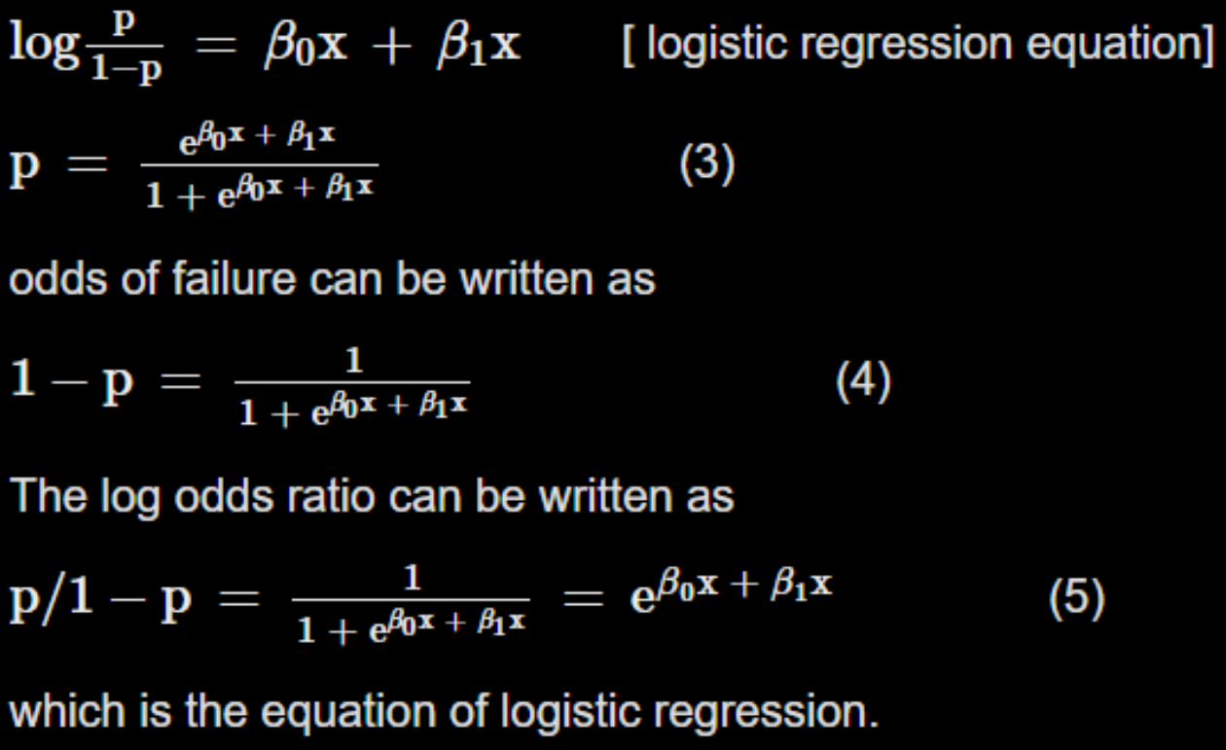

## Why logistic regression is a type of regression

Logistic regression is a supervised learning algorithm used to predict a dependent categorical target variable. In essence, if you have a large set of data that you want to categorise, logistic regression may be able to help. For example, if you were given a dog and an orange and you wanted to find out whether each of these items was an animal or not, the desired result would be for the dog to end up classified as an animal, and for the orange to be categorised as not an animal. Animal is your target; it is dependent on your data in order to be able to classify the item correctly. In this example, there are only two possible answers (binary logistic regression), animal or not an animal. However, it is also possible to set up your logistic regression with more than two possible categories (multinomial logistic regression).

Logistic Regression and GLM,

Generalized Linear model,

Predicted values from Logistic Regression,

Interpreting the coefficients and odds ratios

Linear and Logistic Regression: similarities and Differences

Assessing the models.

## Logistic Response function

The logistic response function, also known as the logistic function or the sigmoid function, is a mathematical function used in logistic regression to model the relationship between a binary response variable and one or more predictor variables.

The logistic function is defined as:

f(x) = 1 / (1 + e^(-x)) where x is the input to the function.

The output of the function, f(x), is a value between 0 and 1, which can be interpreted as the probability that the response variable takes the value 1, given the value of the predictor variable(s). The logistic function has an S-shaped curve, which starts at 0 when x approaches negative infinity, increases smoothly towards 0.5 as x approaches 0, and then levels off towards 1 as x approaches positive infinity. This curve is useful for modelling binary outcomes that are influenced by one or more predictor variables.

In logistic regression, the logistic response function is used to transform the linear combination of the predictor variables and their coefficients into a predicted probability of the binary response variable taking the value 1. The coefficients are estimated using maximum likelihood estimation, and the predicted probabilities can be used to make predictions about new observations or to calculate measures of model performance such as accuracy or area under the receiver operating characteristic curve.

## Generalised linear models

A generalised linear model (GLM) is a statistical framework that extends the linear regression model to handle non-normal distributions and non-continuous response variables. GLMs are used to model the relationship between a response variable and one or more predictor variables. In a GLM, the response variable is assumed to follow a probability distribution from the exponential family of distributions, such as the normal, binomial, Poisson, or gamma distribution.

The relationship between the predictor variables and the response variable is modelled using a linear predictor function, which is a linear combination of the predictor variables and their associated regression coefficients. The linear predictor function is then transformed using a link function, which maps the linear predictor to the expected value of the response variable. The link function is typically chosen to match the properties of the response variable and the distribution it follows. q12

For example, in logistic regression, the response variable is binary (0 or 1) and the link function is the logistic function, which maps the linear predictor to the probability of the response variable taking the value 1. In Poisson regression, the response variable is a count variable and the link function is the logarithmic function, which maps the linear predictor to the expected value of the response variable.

GLMs are a flexible framework that can handle a wide range of response variables and predictor variables, including categorical and continuous variables, and can account for overdispersion and heteroscedasticity. They can also incorporate interaction terms and higher order terms to capture more complex relationships between the response variable and the predictor variables.

GLMs are commonly used in many fields such as biology, engineering, social sciences, and economics, to model a wide range of phenomena, including disease incidence, financial returns, and consumer behaviour.

Module 3 – Times Series Analysis

A time series is a collection of observations or data points taken at regular time intervals over a period of time. The time series data can be used to analyse trends, patterns, and seasonal fluctuations over time.

Time series analysis is a statistical technique that is used to analyse and model the behaviour of time series data. applications of time series analysis include:

* Economic forecasting: Time series analysis is used to analyse and forecast economic indicators such as GDP, inflation, and unemployment rates.
* Financial analysis: Time series analysis is used to analyse financial market trends and forecast stock prices, interest rates, and exchange rates.
* Weather forecasting: Time series analysis is used to analyse and forecast weather patterns and climate change.
* Sales forecasting: Time series analysis is used to forecast sales of products or services based on historical sales data.
* Quality control: Time series analysis is used to monitor and control manufacturing processes, detect anomalies, and predict equipment failures.
* Epidemiology: Time series analysis is used to monitor and predict the spread of diseases and outbreaks.
* Traffic analysis: Time series analysis is used to analyse and forecast traffic patterns, which is important for city planning and transportation management.
* Energy demand forecasting: Time series analysis is used to forecast energy demand based on historical usage patterns, which is important for energy companies and utilities.

The four main components of a time series are:

* Trend: This component represents the long-term pattern or direction of the time series. It shows whether the series is increasing, decreasing, or staying relatively constant over time. Various fluctuations but for a longer period of time.
* Seasonality: This component represents the regular, repeating patterns that occur in the time series over shorter periods of time, such as days, weeks, or months. Seasonality is often seen in data related to weather, holidays, or other recurring events.
* Cyclical: This component represents the longer-term, non-repeating fluctuations in the time series that can last for several years or even decades. Cyclical patterns can be caused by factors such as changes in the business cycle, demographic shifts, or changes in government policies.cycles are often irregular both in height of peak and duration.
* Random: This component represents the unpredictable, random fluctuations in the time series that cannot be explained by the other three components. Random variation can be caused by factors such as measurement error, natural disasters, or unexpected events.

## Decomposition

Decomposition is a common technique in time series analysis that separates a time series into its different components: trend, seasonality, cyclical, and random. The process of decomposition involves breaking down the original time series into these four components, each of which can be analysed and modelled separately.

The decomposition process typically involves the following steps:

* Detrending: The trend component is isolated and removed from the time series. This is typically done using a moving average or polynomial regression to smooth out the data and identify the long-term trend.
* Seasonality extraction: The seasonality component is extracted from the detrended time series. This is typically done by analysing the periodic patterns that repeat over shorter time intervals, such as daily, weekly, or monthly cycles.
* Cyclical component identification: The cyclical component is identified by analysing longer-term fluctuations in the time series that do not repeat at regular intervals. This can be done using spectral analysis or other advanced techniques.
* Residual analysis: The random component, or residual, is identified by subtracting the trend, seasonality, and cyclical components from the original time series. The residual component represents the unpredictable, random fluctuations in the data that cannot be explained by the other components.

Additive time series

In an additive time series, the values of the time series are modelled as a sum of the different components: trend, seasonality, cyclical, and random. That is, the time series values at a given time are equal to the sum of the trend, seasonality, cyclical, and random components at that time. an additive model is more appropriate when the magnitude of the seasonal and trend components are relatively constant over time

The additive model is expressed as:

Y(t) = T(t) + S(t) + C(t) + e(t), where Y(t) is the observed value at time t,

T(t) is the trend component, S(t) is the seasonal component, C(t) is the cyclical component, and e(t) is the random component.

Multiplicative time series

In a multiplicative time series, the values of the time series are modelled as a product of the different components: trend, seasonality, cyclical, and random. That is, the time series values at a given time are equal to the product of the trend, seasonality, cyclical, and random components at that time.while a multiplicative model is more appropriate when the magnitude of the seasonal and trend components vary with time.

The multiplicative model is expressed as:

Y(t) = T(t) × S(t) × C(t) × e(t), where Y(t) is the observed value at time t, T(t) is the trend component, S(t) is the seasonal component, C(t) is the cyclical component, and e(t) is the random component.

Autocorrelation ACF stands for Autocorrelation Function, which is a statistical tool used in time series analysis to measure the correlation between a time series and its lagged values. In time series analysis, autocorrelation refers to the correlation between a time series and its own past values. The ACF function calculates the correlation coefficient between a time series and its lagged values, where the lag is the time between the observation and its corresponding lagged value. The ACF is a plot of the correlation coefficient as a function of the lag. The correlation coefficient ranges from -1 to 1, where a value of 1 indicates a perfect positive correlation (i.e., the series and its lagged value are identical), 0 indicates no correlation, and -1 indicates a perfect negative correlation. Interpreting the ACF plot is important in time series analysis, as it can provide insights into the underlying patterns in the data. For example: If the ACF plot shows a significant correlation at lag 1 (i.e., the first lag), this may indicate the presence of a strong trend in the data. If the ACF plot shows a significant correlation at regular lags (e.g., lags 12, 24, 36, etc.), this may indicate the presence of seasonality in the data. If the ACF plot shows a gradual decline in correlation as the lag increases, this may indicate that the series is stationary and that there is no long-term trend or seasonality. If the ACF plot shows a sharp decline in correlation at a specific lag, this may indicate the presence of an autoregressive (AR) or moving average (MA) component in the data. Overall, the ACF plot is a useful tool for understanding the underlying patterns in a time series and identifying potential models that can be used for forecasting and analysis. PACF PACF stands for Partial Autocorrelation Function, which is another statistical tool used in time series analysis to measure the correlation between a time series and its lagged values, but with the effects of intermediate lags removed. In time series analysis, partial autocorrelation refers to the correlation between a time series and its own past values, after removing the effects of intermediate lags. The PACF function calculates the correlation coefficient between a time series and its lagged values, after removing the effects of intermediate lags. The PACF is a plot of the correlation coefficient as a function of the lag, similar to the ACF plot. However, unlike the ACF plot, which includes the effects of all intermediate lags, the PACF plot only includes the direct effect of each lag. Interpreting the PACF plot is important in time series analysis, as it can provide additional insights into the underlying patterns in the data, beyond what can be seen in the ACF plot. For example: If the PACF plot shows a significant correlation at lag 1 (i.e., the first lag), this may indicate the presence of a strong autoregressive (AR) component in the data. If the PACF plot shows a significant correlation at regular lags (e.g., lags 12, 24, 36, etc.), this may indicate the presence of seasonality in the data. If the PACF plot shows a sharp decline in correlation after a few lags, this may indicate that an AR model of low order (i.e., few lagged terms) is appropriate for modelling the data. Overall, the PACF plot is a useful tool for understanding the underlying patterns in a time series and identifying potential models that can be used for forecasting and analysis, especially when the ACF plot is not sufficient for identifying the appropriate model.

## 

## 

## 

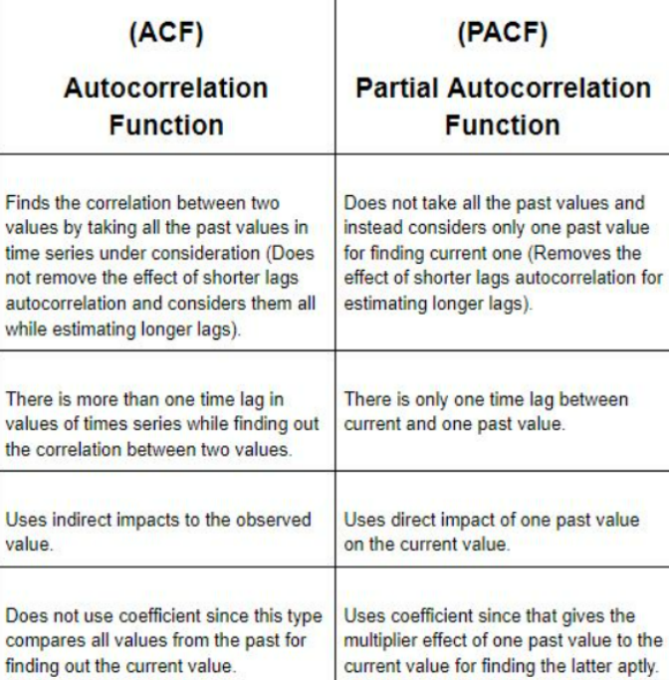

## Evaluation of Time series methods

The evaluation of time series methods involves assessing the performance of various forecasting models to determine which one provides the best fit to the data and produces the most accurate forecasts. There are several commonly used methods for evaluating time series methods, including: Mean Absolute Error (MAE): This is a measure of the average absolute difference between the actual and forecasted values. It provides a measure of how accurate the forecasts are on average, and lower values indicate better performance. Root Mean Square Error (RMSE): This is similar to MAE, but it takes into account the squared errors between the actual and forecasted values. RMSE is a popular metric for comparing different forecasting methods, as it emphasises larger errors more than MAE. Mean Absolute Percentage Error (MAPE): This is a relative measure of forecast accuracy, calculated as the average absolute percentage difference between the actual and forecasted values. MAPE is useful for comparing the accuracy of different forecasting methods across different datasets and scales. Symmetric Mean Absolute Percentage Error (SMAPE): This is another relative measure of forecast accuracy that takes into account the average of the actual and forecasted values. SMAPE is useful when the actual and forecasted values are close to zero, as it prevents division by zero. Theil's U-Statistic: This is a measure of the ratio of the RMSE of a given forecasting method to the RMSE of a naive forecasting method (e.g., using the previous value as the forecast). A value less than 1 indicates better performance than the naive method. Forecast Error Variance Decomposition (FEVD): This is a method for decomposing the variance of the forecast errors into components due to different sources of uncertainty, such as model error, measurement error, and external shocks. FEVD can help identify which sources of uncertainty are most important for a given dataset and forecasting method.

## Building and Evaluating an ARIMA Model

ARIMA (Autoregressive Integrated Moving Average) models are a class of statistical models used for time series forecasting. ARIMA models capture the autocorrelation, trend, and seasonality in a time series by combining autoregressive (AR), differencing (I), and moving average (MA) components.

The order of an ARIMA model is denoted as (p, d, q), where p is the order of the AR component, d is the order of differencing, and q is the order of the MA component. The choice of the order of an ARIMA model is typically based on visual inspection of the time series, **autocorrelation function (ACF)** and **partial autocorrelation function (PACF)** plots, and statistical measures such as the **Akaike Information Criterion (AIC)** or **Bayesian Information Criterion (BIC)**.

The Autoregressive (AR) component of an ARIMA model captures the relationship between the current value of the time series and its past values.

The order of the AR component (p) specifies the number of past values to include in the model. For example, an AR(1) model uses only the lagged value of the time series to make the current prediction, while an AR(2) model uses the two most recent lagged values.

The Integrated (I) or Differencing component of an ARIMA model captures the trend or non-stationarity in the time series. The order of differencing (d) specifies the number of times the time series needs to be differenced to make it stationary, i.e., to make the mean and variance of the series constant over time. For example, if the time series exhibits a linear trend, a first-order difference can remove the trend.

The Moving Average (MA) component of an ARIMA model captures the relationship between the current value of the time series and its past forecast errors. The order of the MA component (q) specifies the number of past forecast errors to include in the model. For example, an MA(1) model uses only the lagged forecast error of the time series to make the current prediction, while an MA(2) model uses the two most recent lagged forecast errors.

## Box-Jenkins Methodology

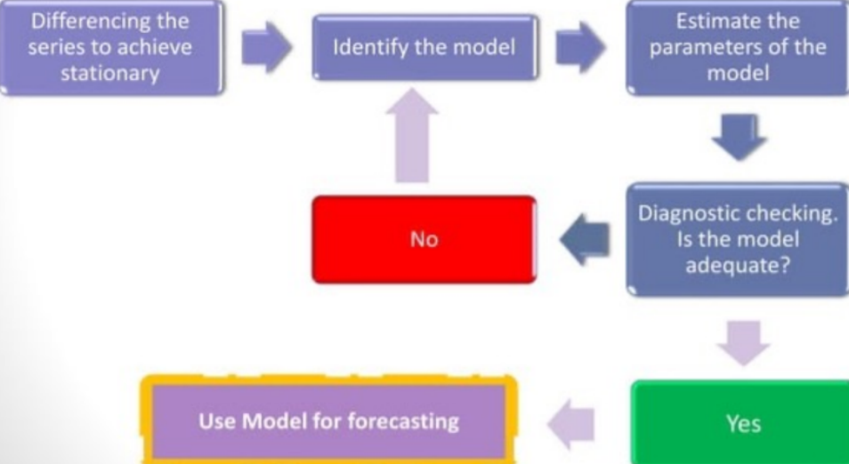

**PHASE I :** Identification and Preparation

1. Data Preparation

Differencing the data to achieve stationary series

Transform data to stabalize variance

1. Model Selection/identification

Shortlist suitable models according to the data

Apply ACF and PACF to determine potential models

**PHASE II :** Estimation and Testing

1. Estimation

Estimate parameters in potential models

Select best model using suitable criteria

1. Diagnostics

Check ACF/PACF of residuals

Do portmanteau test of residuals

**PHASE II :** Forecasting/Application

Using the derived model to forecast future series